`Pac-Poly-Fish Hook-Marshall Islands

Gilbert Islands bonito composite shell fish-hook.

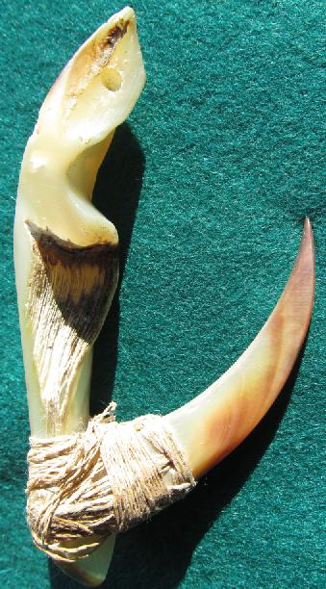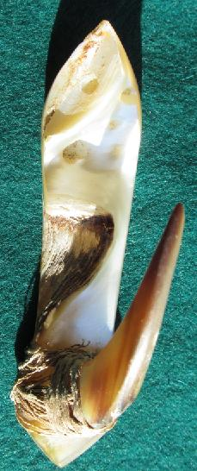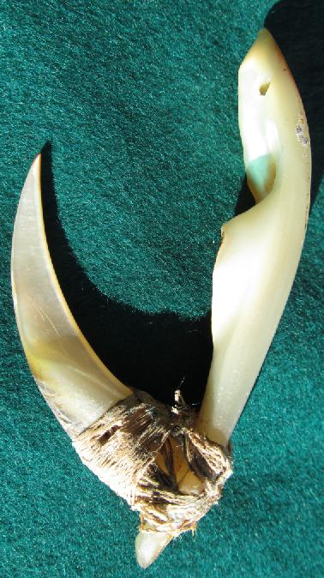

This rare bonito composite shell fish-hook comes from the northern Gilbert Islands, ex Mark Blackburn, Hilo HI, collection. It has also been found on the Marshall Islands (Ratak and Ralik), Mokil Atoll (near Ponape) and the Kusai Islands (Blau, Maaz, Meyer, Picasso 2012: 142-143). Complete hooks in the Marshall Islands are called *Jibon* ("money," in Marshallese): "This is ... the only kind of shell currency that falls into the category of truly functional money, rather than into that of jewelry currency" (Schneider 1905: 10). "Besides the mother of pearl shell kitchen knives on Palau and Yap, this was undoubtedly the only real currency in Micronesia that was derived from a utilitarian object and not a piece of jewelry. Indeed, this 'currency form' was used not only for payment and purchase, but also for catching bonito. This type of mother of pearl fish hook appears to be the only one in all of Oceania that also had currency value. All other hooks were used exclusively for fishing and not as money" (Lautz 1999: 193-194). The method of manufacture that produced such a seemingly crude finish and was obviously never intended to be a piece of jewelry, but it did have a specific utilitarian purpose showing "what native ingenuity can produce from a piece of rough pearl shell, since both barb and shank are of this material, and though as hooks they display but little artistic merit, yet their coarseness is at the same time an accession of strength. Moreover ... were these rough excrescences reduced to a flat surface, the nacre would be destroyed, and the hook as a lure [would] become less efficient" (Beasley 1928: 95). A late nineteenth-century Marshall Islands' missionary, August Erdland, recorded his observations regarding the actual design and manufacture of these fish hooks: " the Marshall Islanders "relied on fish as a main food source, and they like it so much, that they have a real craving for it if they have to spend a few days without it ... . They keenly observe the 'temperaments' of all fish varieties, and how certain species gather at certain times of the year. Useful and effective tools for fishing were the results of their observations ... . Even nowadays, the hook made from the hinge portion of the mother of pearl shell is the best there is for catching larger fish. It is made of a shank and a curving bone or mother of pearl point. For fishing, a piece of light pandanus leaf or a piece of hibiscus bast is attached to the knot in the line, in such a way that the bast or the leaf are aligned at an angle next to the mother of pearl shank, and mimic the wings of a flying fish. To catch bonito the line is attached to the sailing canoe and pulled with short tugs. The bonito are attracted by the gleaming of the mother of pearl shell, attack what they think is the flying fish, and with a quick jerk, the fisherman gets the hook into the fish's palate or the side of its mouth" (Erdland 1914: 47-48).

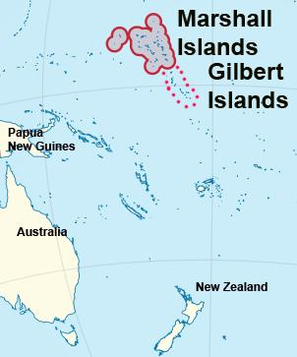

General range of the bonito composite shell fish hook. After http://en.wikipedia.org/wiki/File:Marshall_Islands_on_the_globe

References:

Beasley, Harry G. 1928. *Pacific island records: fish hooks*. London, Seely, Service & Co.

Blau, Daniel, Maaz, Klaus, Meyer, Anthony J. P., Picasso, Sydney. 2012. *Fish hooks of the Pacific Islands : a pictorial guide to the fish hooks from the peoples of the Pacific Islands*. Munich ; London : Daniel Blau ; Munich : Hirmer.

Erdland, August. 1914. *Die Marshall-Insulaner Leben und Sitte, Sinn und Religion eines Südsee-Volkes.* Münster i.Wein, Aschendorff.

Lautz, Thomas. 1999. *Steinreich* *in der Südsee : traditionelle Zahlungsmittel in Mikronesien.* Köln : Geldgeschichtliches Museum, Kreissparkasse.

Schneider, Otto. 1905. *Muschelgeldstudien, nach den hinterlassenen Manuskript bearbeitet von Carl Ribbe*. Dresden : Engelmann's Machfg.